 **Year 8 - Humanities and Social Sciences 2023**

**Assessment 1 A - Parts A and B (10%)**

**Inquiry Task**

**Consumer Protection Laws**

**Name: _______________________________**

|  |  |  |  |
| --- | --- | --- | --- |
| **Your Target** | **Mark** | **Percentage** | **Weighting** |
| **Inquiry**  **/60**  **Poster**  **/50** | **Inquiry**  **/60**  **Poster**  **/50** |  | **10%** |
| **TOTAL MARKS:**  **/110** | | | |

**Date Due: Week 6, Term 4.**

**Date: 13th November (Monday)**

Each year since 2006, Choice magazine has asked consumers to nominate goods or services that it considers are shonky products.

The magazine then tests the products and those that meet it’s shonky criteria are shortlisted, from which the ‘winners’ are announced.

The Shonky Awards Hall of Shame can be accessed via <https://www.choice.com.au/shonky-awards/hall-of-shame>.

Students are to select one of the products that has been awarded a Shonky by Choice in the last five years and complete the task below:

**Section One (PART A): Inquiry Process**

Students will investigate if a product has breached the legal rights of consumers, and if so what action the consumer may request.

* Use the inquiry booklet to record information on the legal rights of consumers.
* ****Choose a product that has been awarded a “Shonky Award” by Choice Magazine.
* Investigate and answer questions relating to your chosen product.
* Complete the PMI Chart. *This is to evaluate the task.*
* Complete a bibliography. *The template can be used to assist you.*

**Section Two (PART B): Poster**

Present your research findings as a poster.

**Your poster must include:**

* Name and description of your chosen product (include the year it received the award).
* Explain why the product was chosen to be a recipient of Choice Magazines “Shonky Awards”.
* Describes the legal rights of consumers with regards to purchasing products.
* Explains what actions, if any, consumers who have purchased this product may request from the supplier and/or producer, and why.
* Identifies and describes legal action, if any, consumers of this product undertook.

*Remember to make the poster both creative and informative. Include images of your chosen products.*

**Section Three (Part C): Validation Questions**

*Answer validation questions in relation to your research inquiry. This part will be completed in conjunction with a test in Week 6.*

**Inquiry Process Booklet**

1. **Identify** the organisation that is the governing body of consumer law in Australia. *(2 marks)*

|  |  |
| --- | --- |
| Acronym: | Full Title: |

1. **Explain** the role of this organisation *(5 marks)*

__________________________________________________________________________________________________________________________________________________________________________________________________________________________________________________________________________________________________________________________________________________________________________________________________________________________________________________________________________________________________________________________________________________________________________________________________________________________________________________________________________________________________________________________________________________________________________________________________________________________________________________________________________________

1. **Describe** what is meant by the term ‘consumer law’ and why it is important for there to be laws that protect consumers. *(4 marks)*

________________________________________________________________________________________________________________________________________________________________________________________________________________________________________________________________________________________________________________________________________________________________________________________________________________________________________________________________________________________________________________________________________________________________________________________________________________________________________________________________________________________________________

Teacher to tick when completed ÿ

Date:­­

Teacher Initial:

1. **Identify** and **explain** five (5) guarantees that the above organisation provides to consumers *(15 marks)*

|  |  |
| --- | --- |
| **Guarantee** | **Explanation** |
| 1. |  |
| 2. |  |
| 3. |  |
| 4. |  |
| 5. |  |

1. **Identify** and **Describe** the three (3) steps in making a consumer complaint to the governing body identified above. *(9 marks)*

|  |  |
| --- | --- |
| **Step** | **Description** |
| **1.** |  |
| **2.** |  |
| **3.** |  |

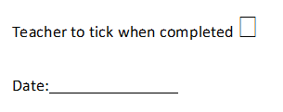

1. **Identify** below the ‘Shonky Award’ winning product you have selected to research, and the year that it was given the award by Choice Magazine.

**_______________________________________________________________________________**

1. **Explain** why your chosen product was the recipient of a ‘Shonky Award’ by Choice Magazine *(4 marks)*

**__________________________________________________________________________________________________________________________________________________________________________________________________________________________________________________________________________________________________________________________________________________________________________________________________________________________________________________________________________________________________________________________________________________________________________________________________________________________________________________________________________________________________________________________________________________________________**

1. **Outline** what legal rights of consumers has been breached by this product. *(3 marks)*

**__________________________________________________________________________________________________________________________________________________________________________________________________________________________________________________________________________________________________________________________________________________________________________________________________________________________________________________________________________________________________________________________________________________________________________________________________________________________________________________________________________________________________________________________________________________________________**

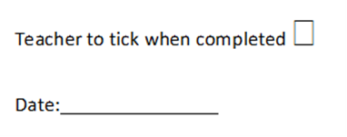

1. **Explain** what actions, if any, consumers who have purchased this product may request from the supplier and/or producer, and why. *(3 marks)*

**________________________________________________________________________________________________________________________________________________________________________________________________________________________________________________________________________________________________________________________________________________________________________________________________________________________________________________________________________________________________________________________________________________________________________________________________________________________________________________________________________________**

1. **Identify** and **describe** legal action, if any, consumers who have purchased this product have entered against the producer. *(3 marks)*

**________________________________________________________________________________________________________________________________________________________________________________________________________________________________________________________________________________________________________________________________________________________________________________________________________________________________________________________________________________________________________________________________________________________________________________________________________________________________________________________________________________**

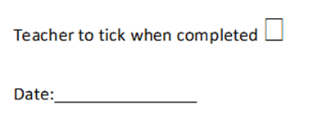

1. **Complete the PMI chart below**

|  |  |  |
| --- | --- | --- |
| P – Plus | M - Minus | I - Interesting |
| Positives (Pluses) about the task Consumer Law | Negatives (Minuses) about the task or Consumer Law | Interesting parts about the task or Consumer Law |
|  |  |  |

Teacher to tick when completed ÿ

Date:­­

Teacher Initial:

|  |  |  |  |  |  |
| --- | --- | --- | --- | --- | --- |
| **Author** | **Date last updated** | **Title of Webpage** | **Date accessed** | **HTTP** | |
|  |  |  |  |  | |
|  |  |  |  |  | |
|  |  |  |  |  | |
|  |  |  |  |  | |
|  |  |  |  |  | |
|  |  |  |  |  | |
| **Author** | **Date of Publication** | **Title of Book** | **Publisher** | | **Place of Publication** |
|  |  |  |  | |  |
|  |  |  |  | |  |
|  |  |  |  | |  |

1. **Reference recording sheet**

*Please note that in order to obtain full marks you must submit a formal bibliography, the table below is only for recording your references as you are researching.*

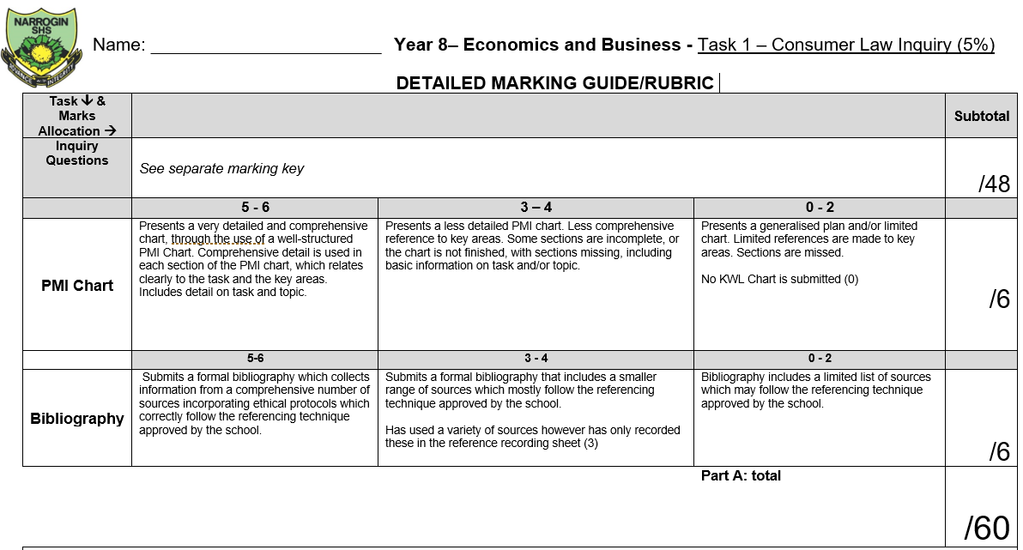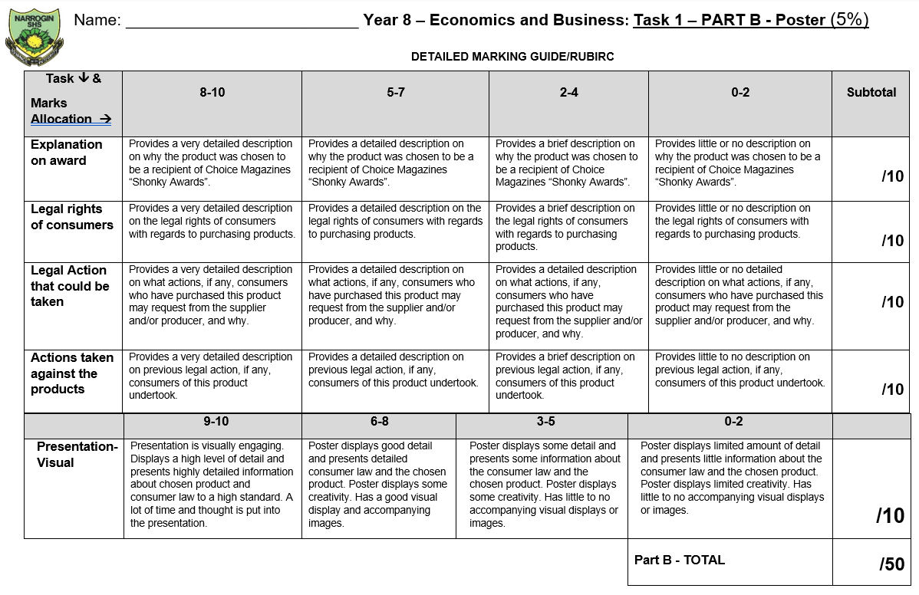

**Feedback:**